Project Design Phase-II

Technology Stack (Architecture & Stack)

|  |  |
| --- | --- |
| Team ID | PNT2022TMID17129 |
| Project Name | GAS LEAKAGE MONITERING AND ALERTING SYSTEM |
| Maximum Marks | 4 Marks |

TECHNOLOGY ARICHITECTURE

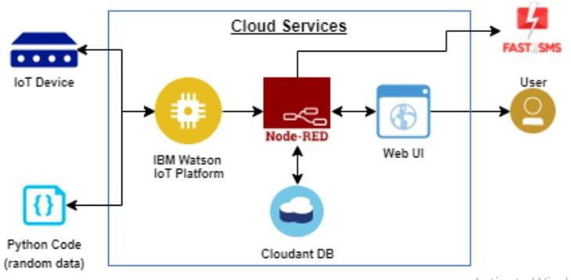

Table-1: Components & Technologies:

|  |  |  |  |
| --- | --- | --- | --- |
| **S.No** | **Component** | **Description** | **Technology** |
| **1.** | User Interface | Mobile App | **IOT Platform** |
| **2.** | Application Logic-1 | Mobile App to identify the Gas leak | **Python** |
| **3.** | Application Logic-2 | Gets the location of the leakage data from database | **IBM Watson IoT API Call data** |
| **4.** | Application Logic-3 | Converts the Data into a text Notification and alert | **IBM Watson Assistant** |
| **5.** | Database | Incident location and kind of leakage | **MySQL** |
| **6.** | Cloud Database | Call the data IBM Cloud is used and userlogin credentials | **IBM DB2, IBM Cloudant** |
| **7.** | File Storage | App code and IoT credentials are stored and APIkeys | **IBM Block Storage** |
| **8.** | External API-1 | To get the status of location of gas leak | **IBM box status API** |
| **9.** | External API-2 | To get the login credentials in IBM DB2 | **Username and Password API** |
| **10.** | Machine Learning Model | To convert the Gas leak location and to alert for averting Incident | **Notification alert** |
| **11.** | **Infrastructure (Server / Cloud)** | **To host the server and application** | **Cloud Foundry, Node Red** |

Table-2: Application Characteristics:

|  |  |  |  |
| --- | --- | --- | --- |
| **S.N Characteristics o** | | **Description** | **Technology** |
| **1.** | Open-Source Frameworks | To develop the application interface, we use  **IOT Device** | **IOT Device** |
| **2.** | Security Implementations | To secure the users login credentials and personal information | **IBM Watson IOT platform** |
| **3.** | Scalable Architecture | To scale the application database | **IBM Auto scaling** |
| **4.** | Availability | To make use the application and data are available 24/7 | **IBM Cloud load balancer** |
| **5. Performance** | | **To increase the performance the application in hosted in the**  **high-performance instance** | **IBM instance** |